Lab 5

Question 1
Employees hired in January 1996 (with full name, email, phone, sorted by last name)
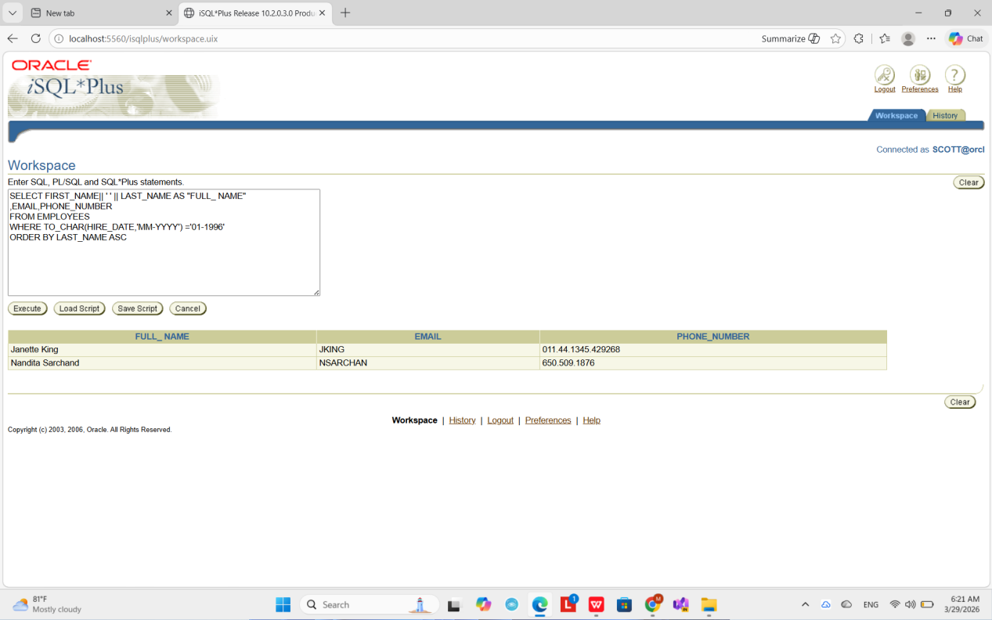
Question 2

Employees hired after December 1999 (descending order by hire date)

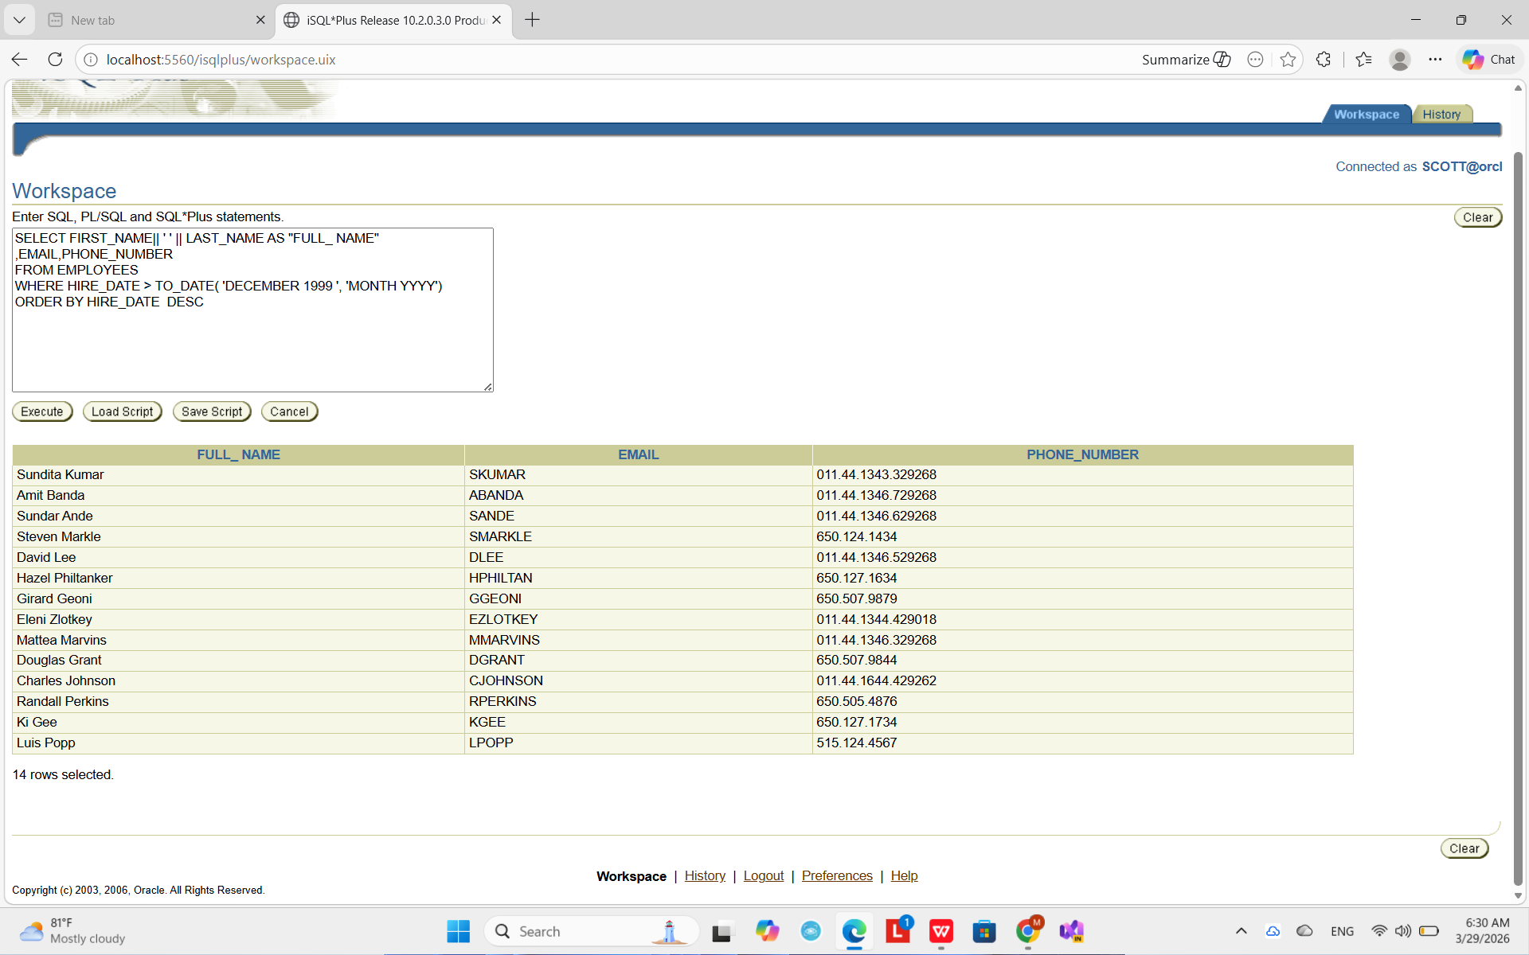

Question no 3
First name starts with 's' and ends with 'n'
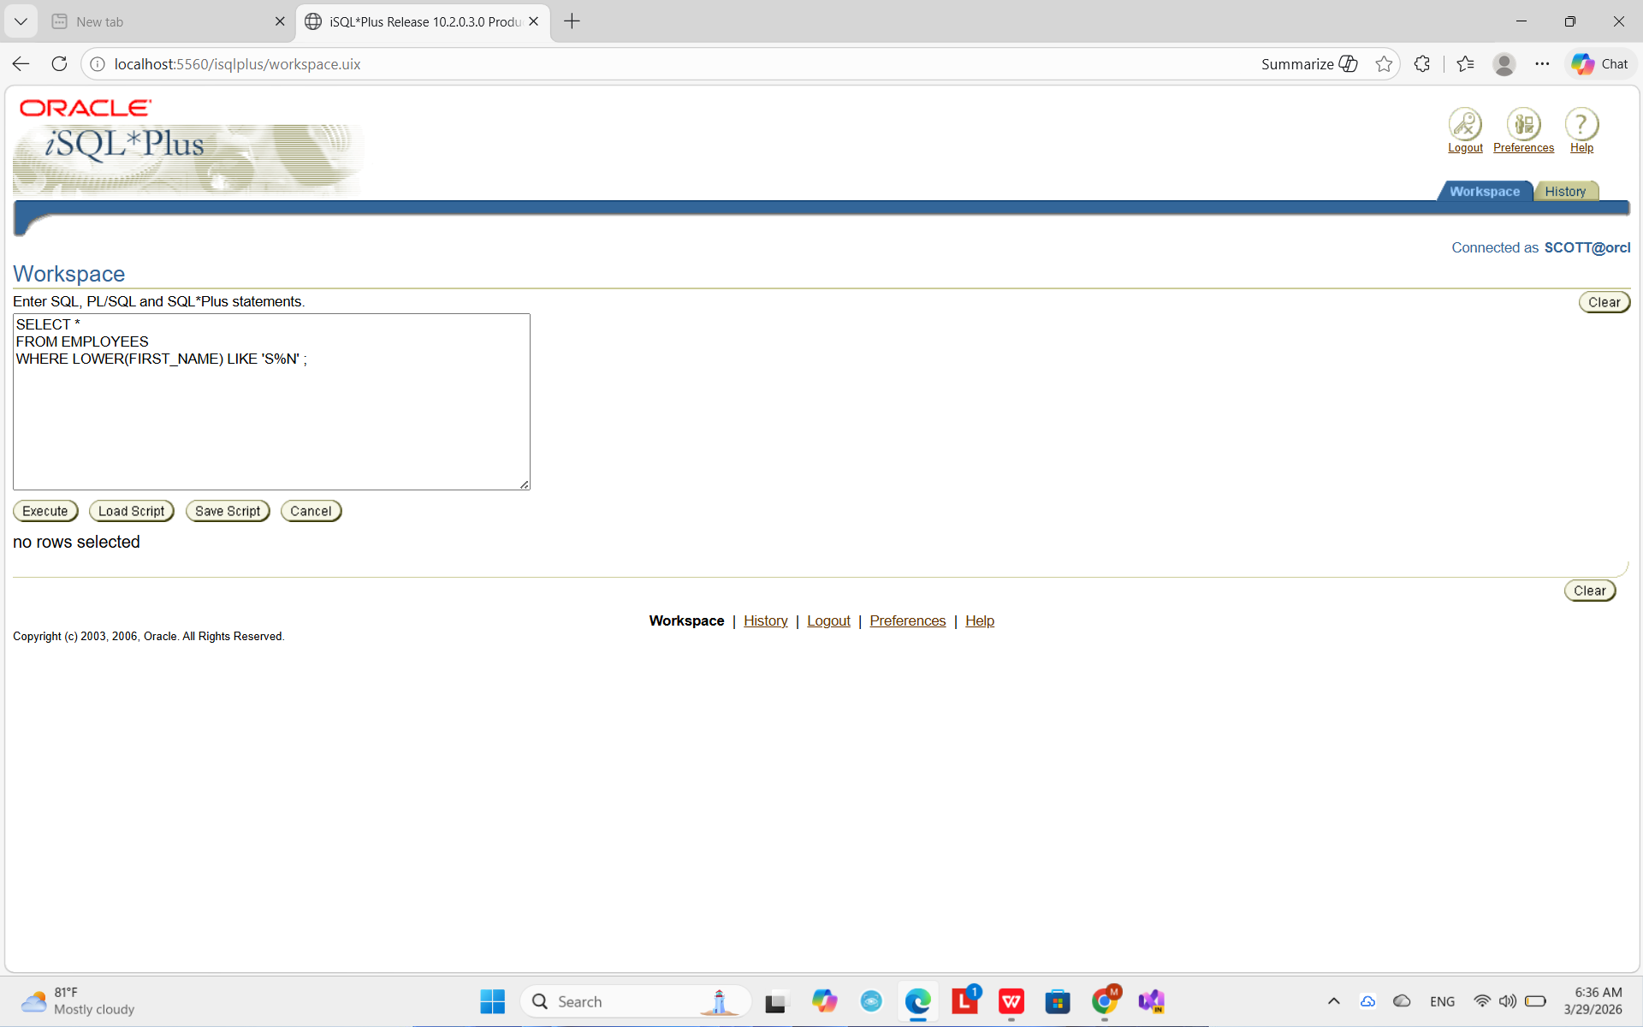

Question no 4
Employees with specific job titles

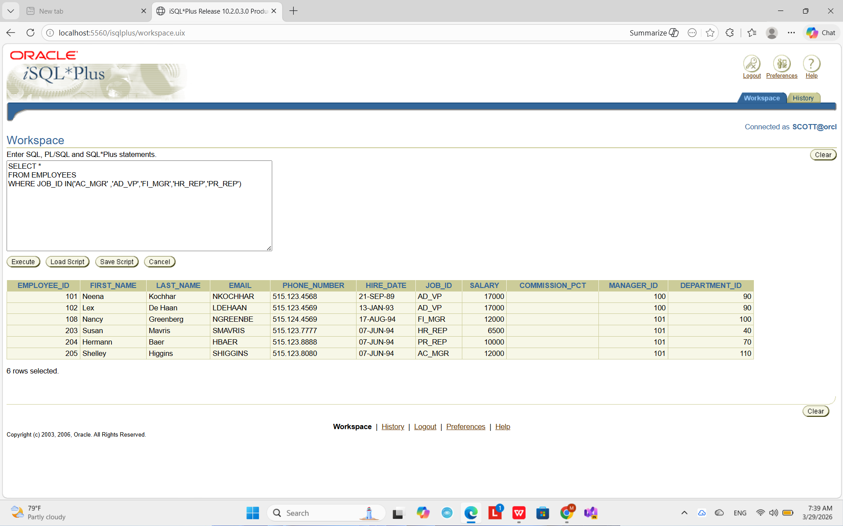

Question no 5
Dynamic report using substitution variable (Department ID)

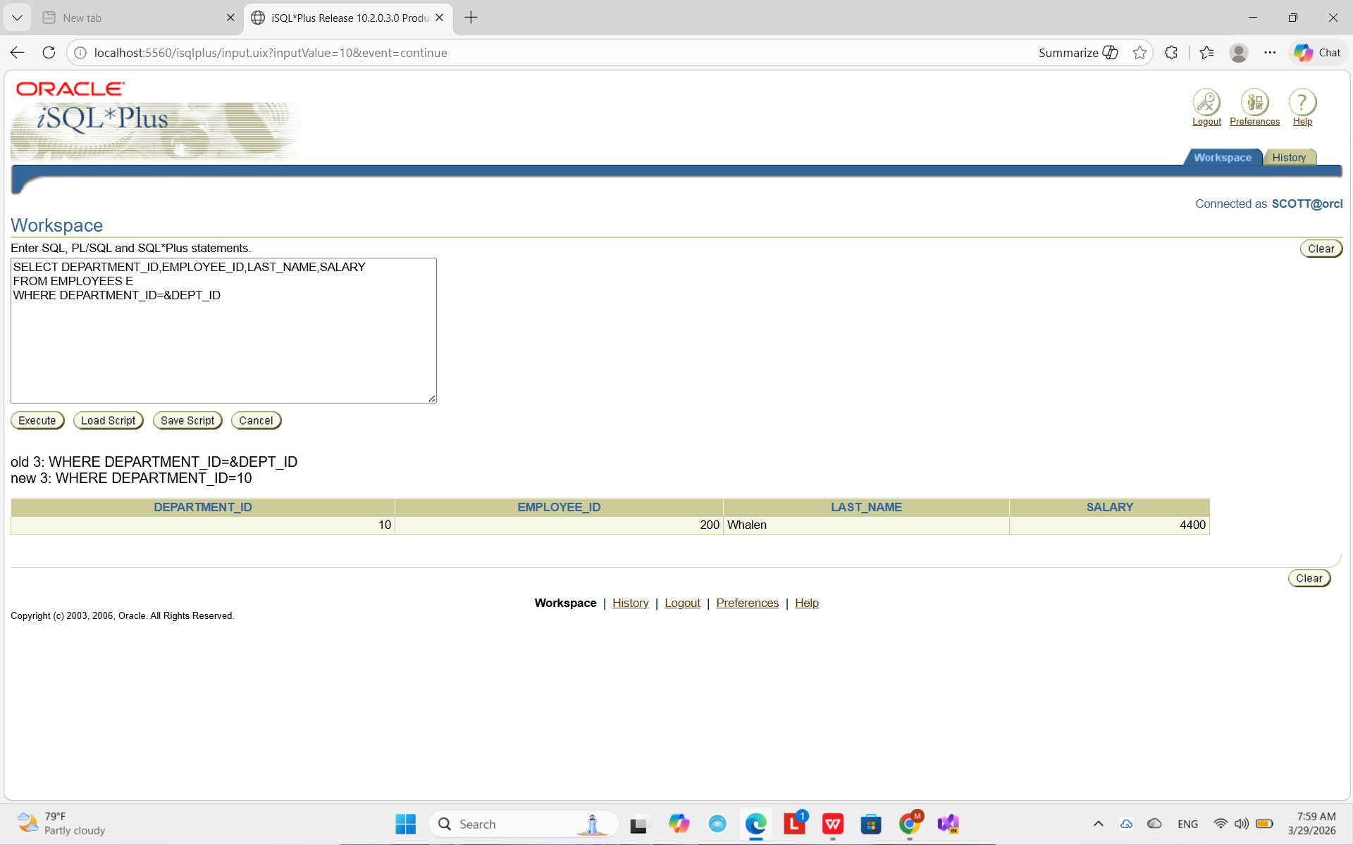

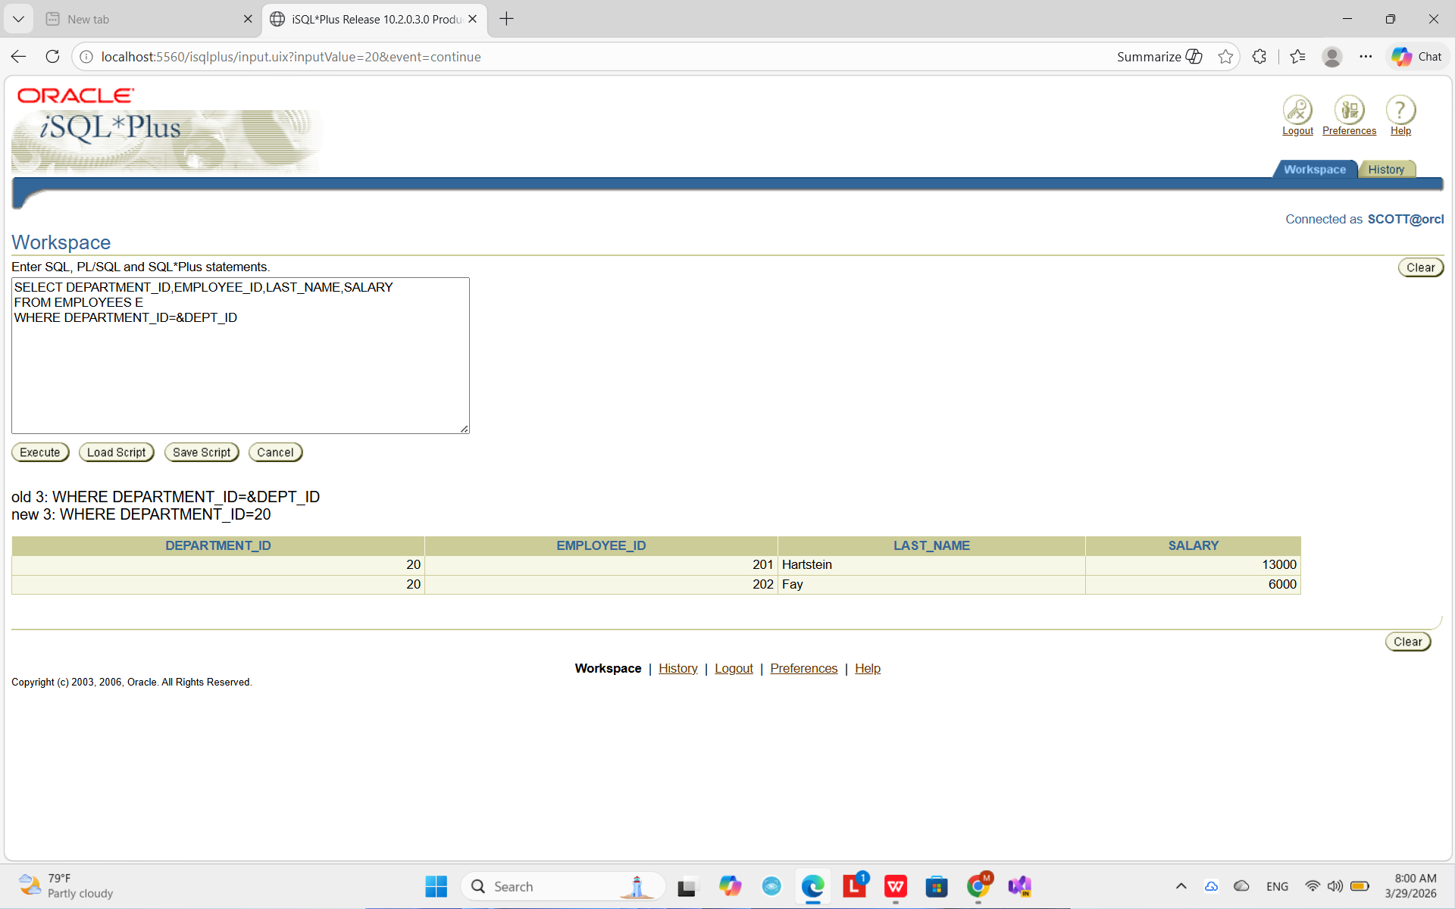

]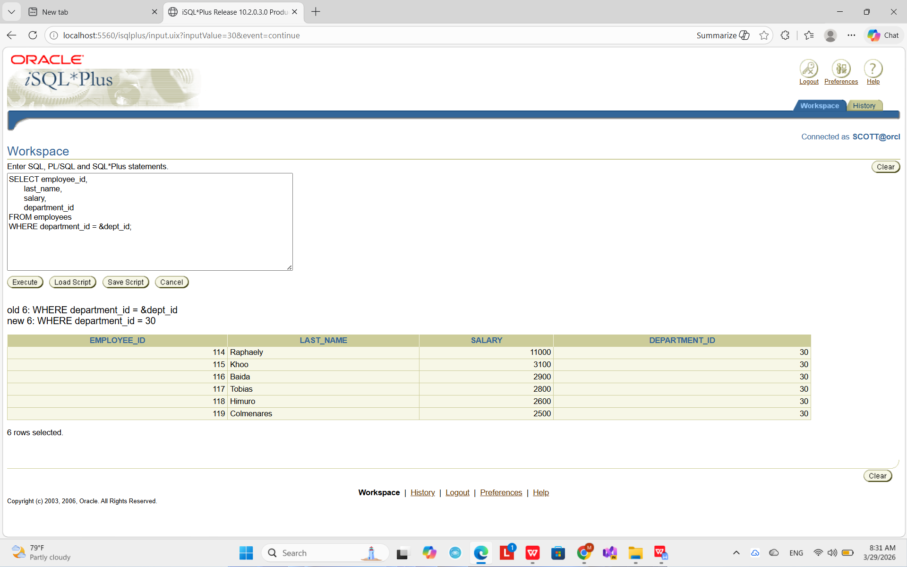

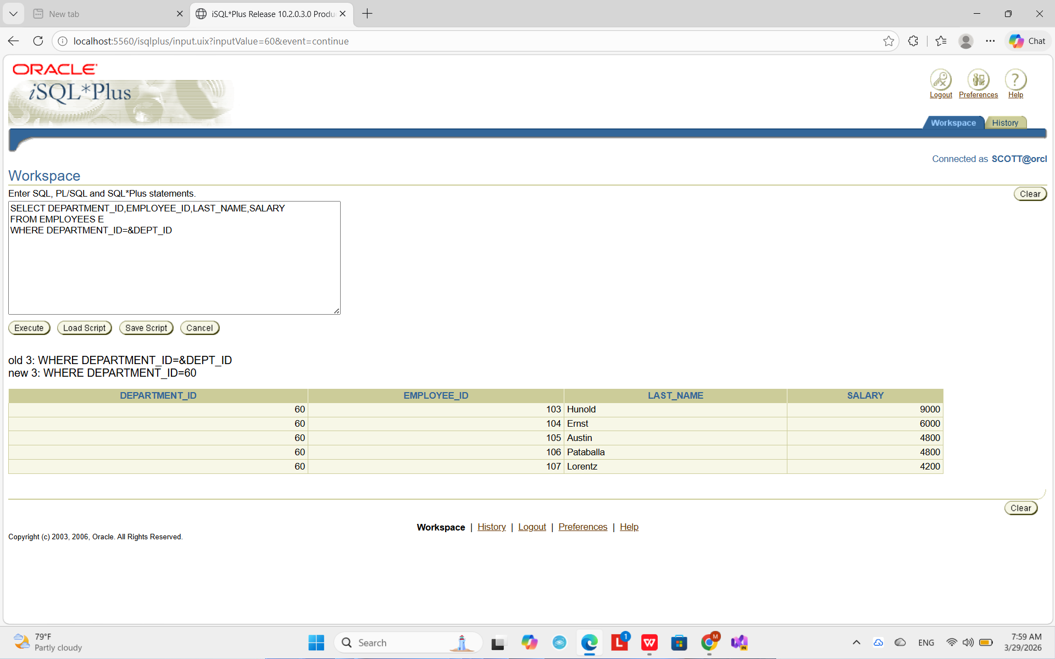

Question no 6
Rooms with price above $40 (sorted by type and price)

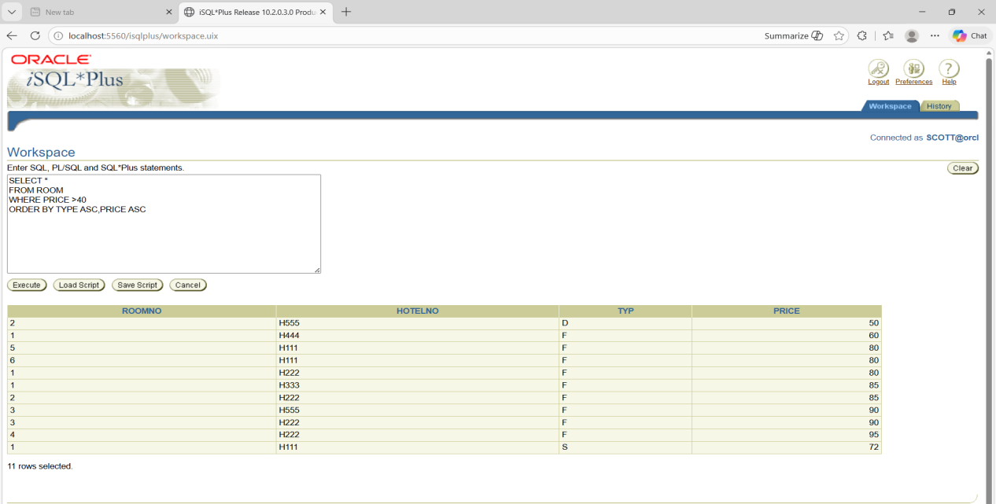

Question no 7
Guests living at “8 Mount St.” (name + full address)

